|  |  |  |  |  |  |
| --- | --- | --- | --- | --- | --- |
| Semester | 202510 | | Division | | CIS |
| Assessment title in Syllabus | Project | | Program | | Data Science |
| 1 |  | |  | |  |
| Course Code | CIS 2423 | | | | |
| Course Title | Programming for Data Science | | | | |
| CLOs | All CLOs | | Accreditation Body | | CAA & CIPS |
| Course Instructor | Dr. Mashal Alqudah | | CRN | | 14350 |
| Assessment Weight | 40% | | Submission Date | | Week 14 |
| For Group Work submissions, an additional individual assessment will be conducted.  Grades for the students in one group will vary based on individual performance in the additional assessment. | | | | | |
|  | | | | | |
| Student Declaration:  Academic Integrity Statement  In accordance with the HCT Academic Integrity Policy  • Students are required to refrain from all forms of academic integrity breaches as defined and explained by HCT.  • A student found guilty of having committed acts of academic integrity breach(es) will be subject to the relevant sanctions as outlined by HCT.  إفادة النزاهة الأكاديمية  وفقًا لسياسة كليات التقنية العليا للنزاهة الأكاديمية  • على الطلبة الالتزام بلوائح وقواعد النزاهة الأكاديمية، كما هو مبيّن وموضح في السياسات والإجراءات الخاصة بكليات التقنية العليا.  • في حالة ارتكاب الطالب أي شكل من أشكال الإخلال بالنزاهة الأكاديمية، سيتعرض الى العقوبات الموضحة في السياسات ذات الصلة.  This assignment is entirely my own work except where I have duly acknowledged other sources in the text and listed those sources at the end of the assignment.  I have not previously submitted this work to the HCT, or any other entity. I understand that I may be orally examined on my submission. | | | | | |
|  | | | | | |
| Student Name(s): | Bashayer Matar | Ghala Saif | | Latifa Mohammed | |
| Student HCT ID(s): | H00535689 | H00537723 | | H00535509 | |

**Course Work Project**

Table of Contents

CLO1/Define Data Analysis Purpose 4

CLO1/Identify and Justify Programming Type for Data Analysis 4

CLO1/Identify Type and Purpose of Machine Learning Algorithm 4

CLO1/Identify and Justify Independent and Dependent Variables 4

CLO2/Justify Performing Descriptive Analysis on Dataset 5

CLO2/Develop Python Function for Descriptive Statistics 5

CLO2/Find the Descriptive Statistics for Dependent Variables 6

CLO2/ Create A Script for Systematic Sampling 7

CLO2/ Detailed Descriptive Stats Report for Dependent Variable 8

Descriptive Statistical Analysis Report 8

CLO2/ Visualize Dependent Variable Using Python Charts 11

Scatter Plot 11

Boxplot 12

Histogram 12

Heat Map 13

CLO2/ Perform Hypothesis Test for Correlation Between Variables 14

Pearson 14

Spearman 14

Chi-Square 15

CLO2/ Assess Dependent Variable Performance Using One-Sample T-Test 15

Shapiro-Wilk test 15

One-Sample T-Test 16

CLO3/ Build, Train, Develop and Evaluate using Simple Regression for chosen dataset 16

CLO3/Develop a script to forecast the value of the dependent variable from all the relevant independent variables using multiple linear regression. 18

Extracting Independent and Dependent Variables 18

Training And Evaluating Multiple Linear Regression Model 19

clo3/Predict the Value of the Dependent Variable from the Different Classifier Such as Logistic Regression, KNN, Naïve-Bayes and Decision Tree 19

Logistic Regression 19

K-Nearest Neighbors (KNN) 20

Naïve Bayes (NB) 21

Decision Tree (DT) 21

CLO 3 /Evaluate the Performance of Each Model Using Confusion Matrix and Accuracy and Identify the Best Fit Classifier for the Chosen Dataset. 22

CLO3 /Predict the Dependent Variable by Using Best-Fit Classifier. 22

CLO3/Perform the Cluster Analysis Such As K-Means and Horizontal 23

K-Means 23

Horizontal 25

CLO3 /Strategy to Improving the System After Viewing the Cluster Diagram 26

CLO4/Create A New Repo for Project in Git Hub 26

CLO4/Configure Git with GitHub 26

CLO4/Clone Git Hub Repo to Git 26

CLO4/Pull Any File from Git Hub Repo to Git 26

CLO4/Modify the Pulled File and Push the Modified File to Git Hub 26

Conclusion 27

Individual Oral Defense 27

# CLO1/Define Data Analysis Purpose

This project's purpose is to examine information from 10,000 used automobile listings in the United Arab Emirates, including make, model, year, mileage, and price. Understanding how various automotive attributes impact used car prices in the UAE market is the aim. By looking at the data, we want to find trends and connections, including how a car brand, model year, or mileage affects its cost. This analysis will assist in brand comparison, buyer preference analysis, and automotive value prediction. The knowledge acquired can help dealerships, customers, and sellers make more informed, data-driven decisions about pricing and purchases.

# CLO1/Identify and Justify Programming Type for Data Analysis

This project was developed using the Python programming language. Python is ideal for data analysis since it's easy to learn and includes useful modules like:

1. Pandas: Data organization and exploration.
2. Seaborn with Matplotlib: Produce eye-catching and tidy graphs.
3. Scikit-learn: Simple machine learning model implementation.

Real data science projects are where Python is most frequently utilized. Its community support, resources, and adaptability make it ideal for working with and efficiently analyzing student data.

# CLO1/Identify Type and Purpose of Machine Learning Algorithm

To forecast used car prices based on make, model, year, and mileage, we employed regression techniques, primarily Simple Linear Regression and Multiple Linear Regression. Since the result (price) is a continuous numerical number, this regression approach is suitable.

**Regression Models:** To examine the impact of a single factor, such miles, on the cost of an automobile, Simple Linear Regression was employed. The impact of multiple features on pricing was examined using multiple linear regression.

**Why Regression?** Since categorizing cars into groups was not the aim; rather, it was to forecast precise car values. The relationship between a car's attributes and its market value in the United Arab Emirates can be better understood through regression analysis.

# CLO1/Identify and Justify Independent and Dependent Variables

**Independent variables:**

* Make (vehicle brand)
* Model (car type)
* Year (year of manufacture)
* Mileage

**Dependent variable:**

* Price (Vehicle Cost)

Information from the independent factors aids in the prediction of the dependent variable. These variables affect the car's pricing; for instance, cars with higher mileage typically cost less, whereas newer models or specific brands typically cost more.

# CLO2/Justify Performing Descriptive Analysis on Dataset

Since it provides a clear initial glance at the UAE used automobile data, descriptive analysis is crucial. It is beneficial to respond to inquiries such as:

1. What is the average automobile price?
2. Which models or brands are most popular?
3. What impact do year or mileage have on the total pricing range?

We can comprehend the distribution and trends in car costs and characteristics by using descriptive statistics like mean, median, mode, and standard deviation. To properly clean and prepare the data before creating machine learning models, it also helps us identify anomalous data (outliers), such as cars with extremely high pricing or severe mileage.

To put it briefly, descriptive analysis helps us comprehend the dataset before implementing algorithms, laying out the groundwork for more in-depth analysis and prediction.

# CLO2/Develop Python Function for Descriptive Statistics

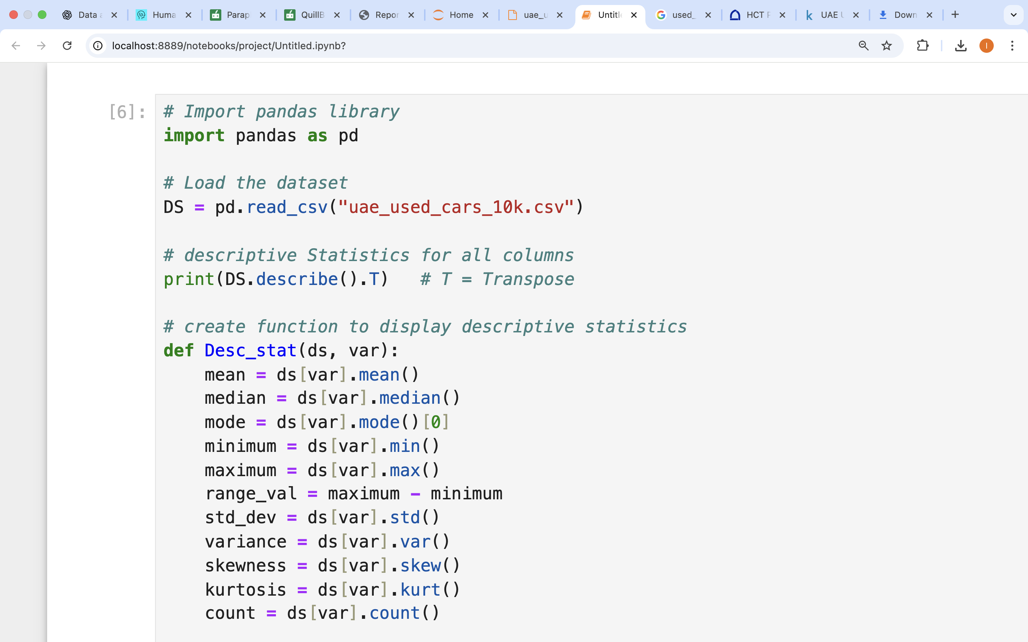

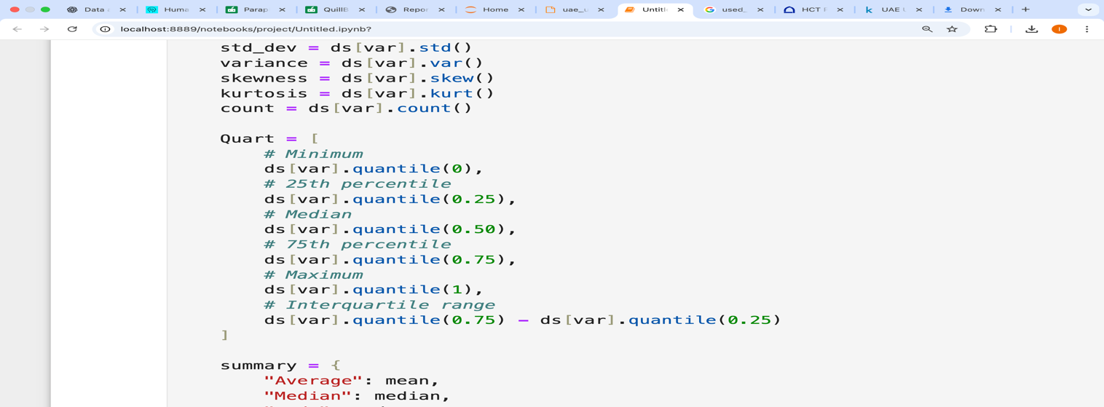

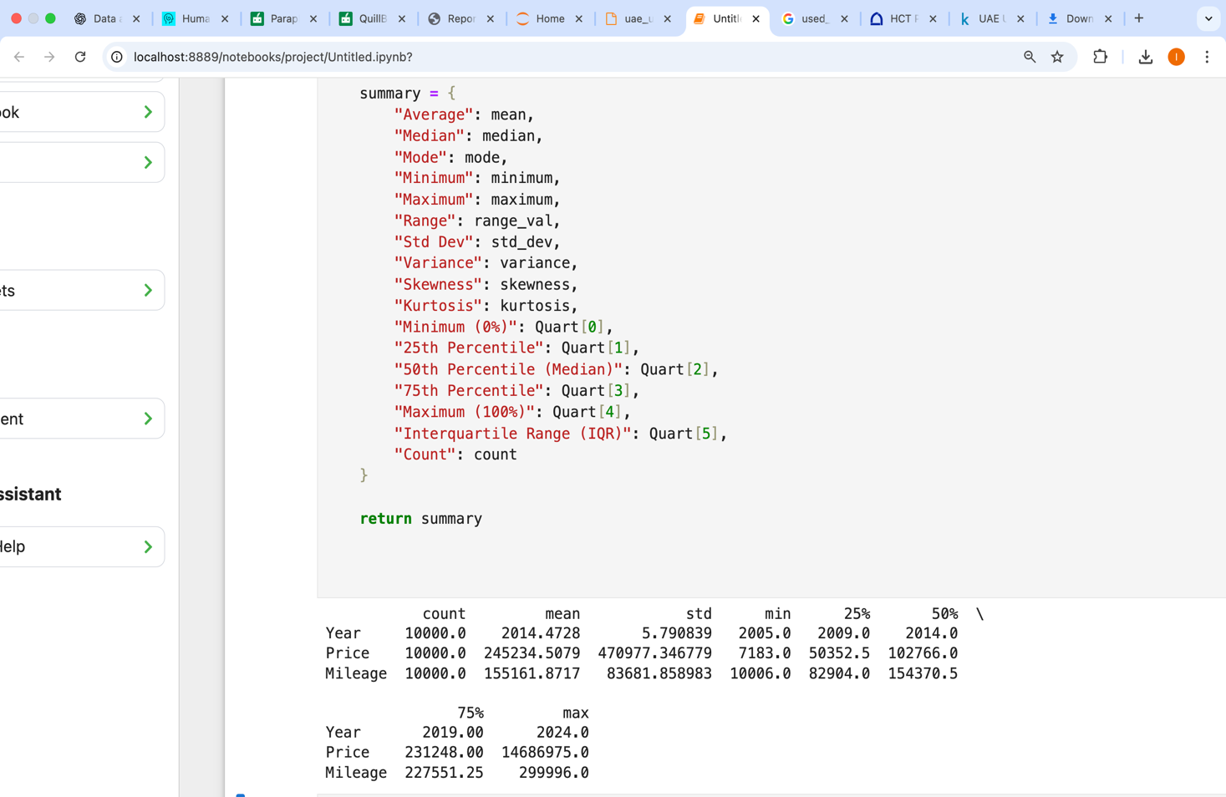

# CLO2/Find the Descriptive Statistics for Dependent Variables

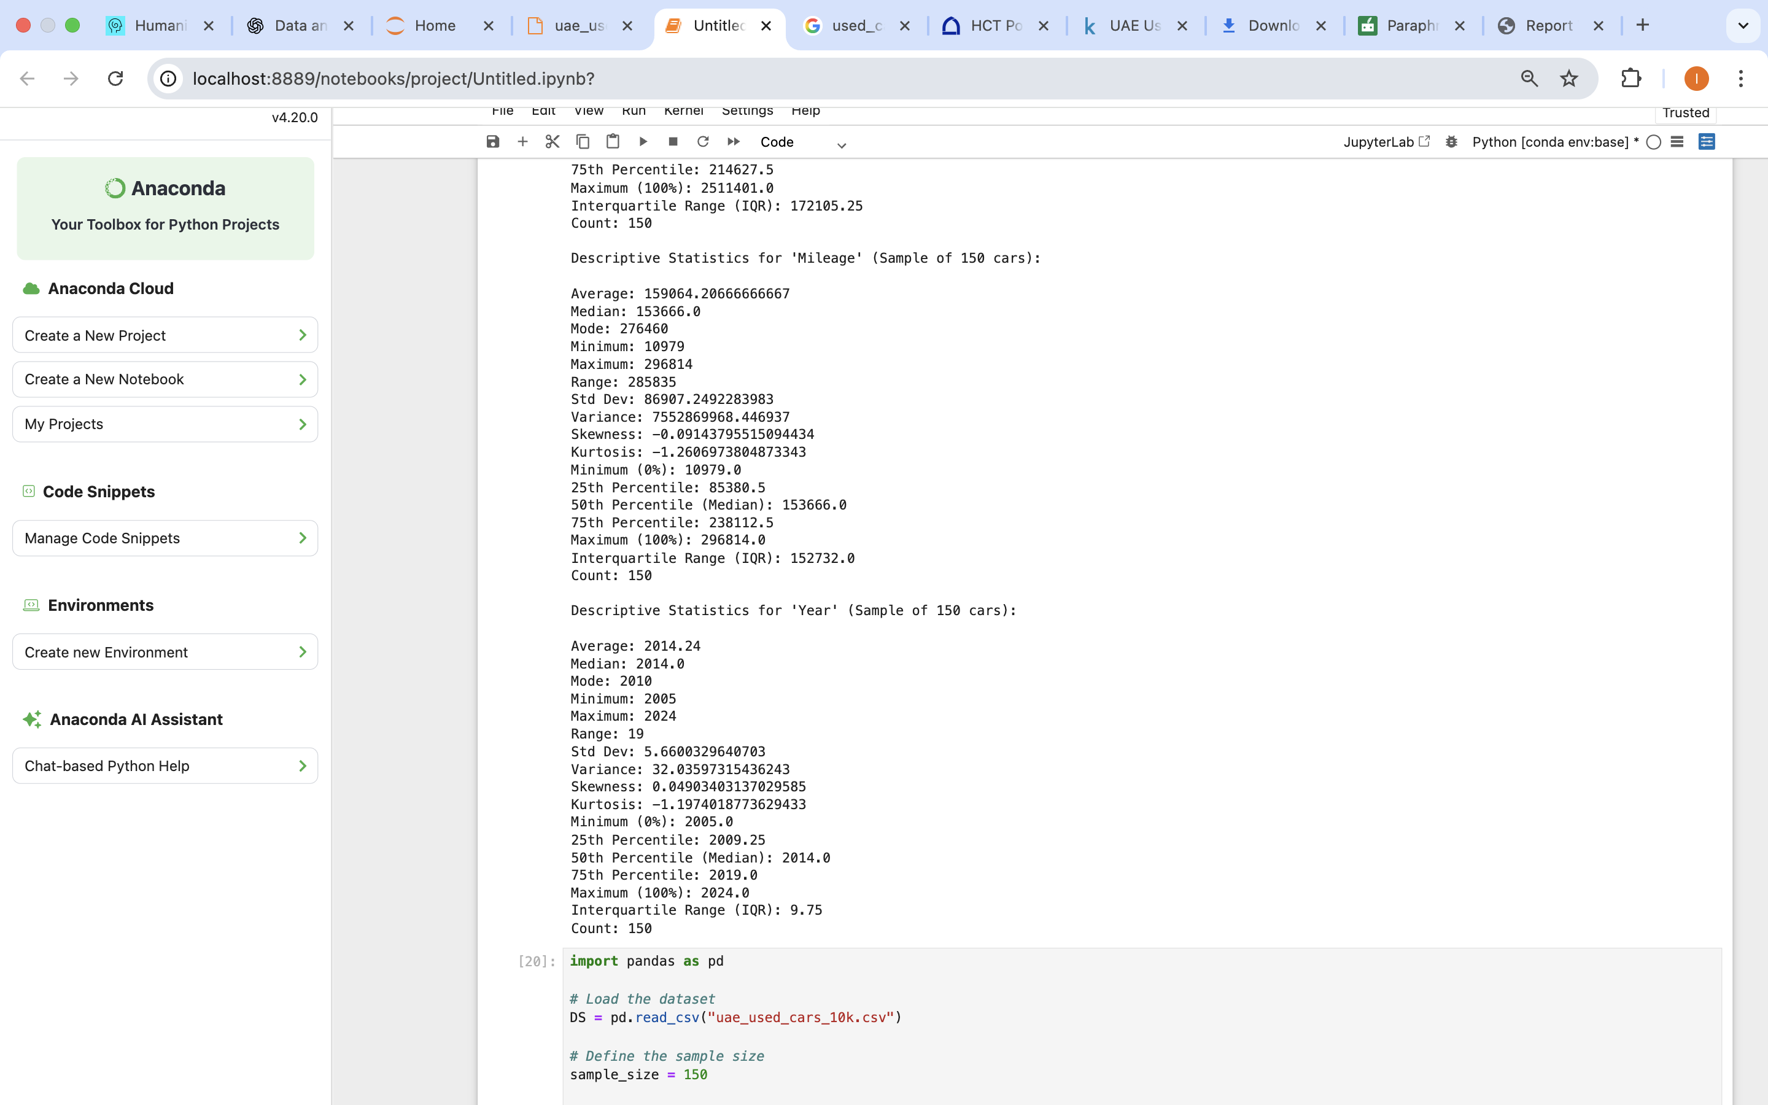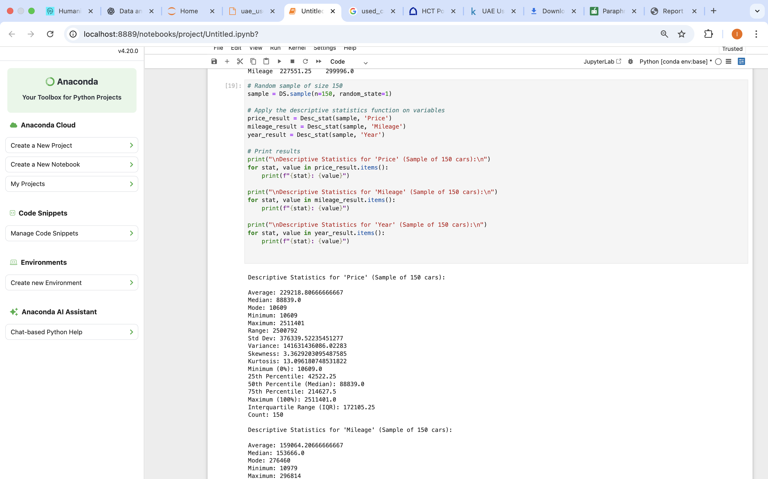

# CLO2/ Create A Script for Systematic Sampling

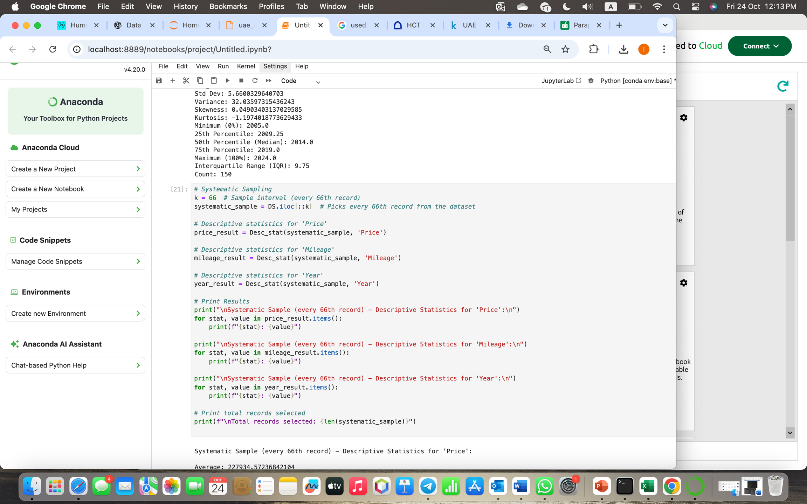

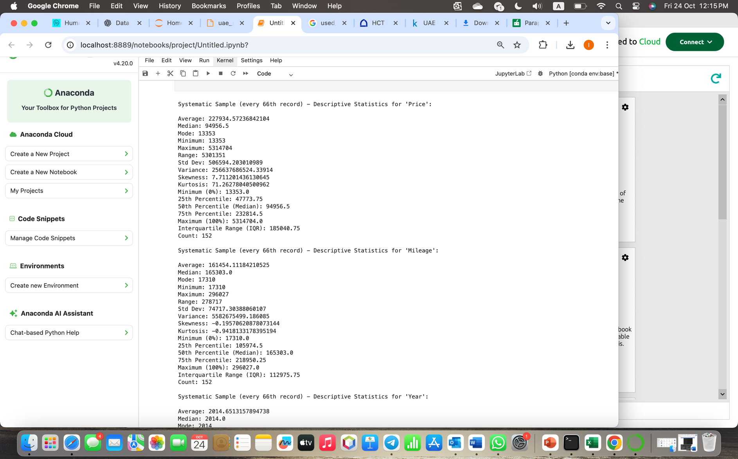

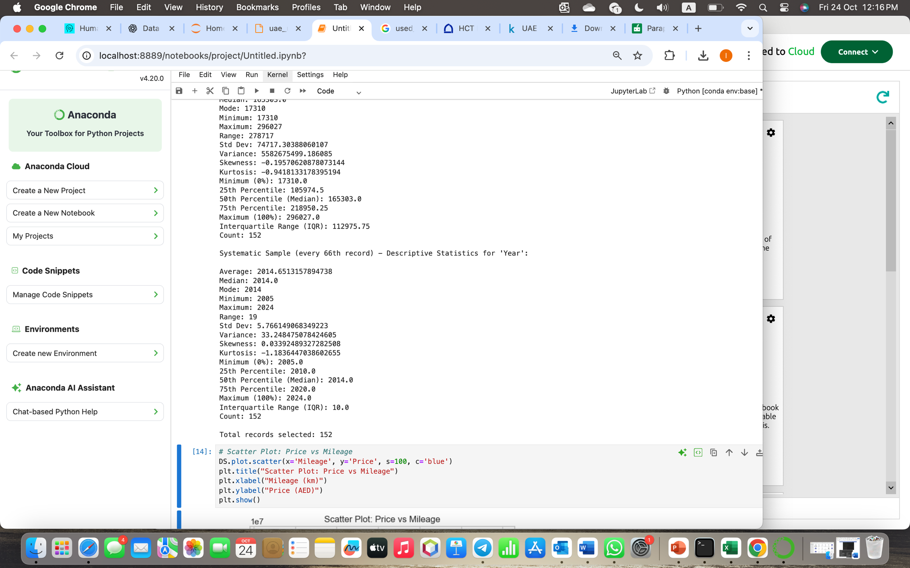

# CLO2/ Detailed Descriptive Stats Report for Dependent Variable

### Descriptive Statistical Analysis Report

This report will analyze UAE Used Car Data based on three significant dependent variables — Price, Year, and Mileage. The analysis will be undertaken using the entire dataset (10,000 cars), a random sample (150 cars), and a systematic sample (every 66th car, 152 cars). The objective is to identify how car prices, model years, and mileage vary across the UAE used car market.

#### Analysis of Variables

##### Full Dataset (10,000 Cars)

* **Dependent Variable:** Price
* **Average (Mean):** 245,234 AED — total cost of used cars in the UAE.
* **Standard Deviation:** 470,977 AED — enormous range due to the presence of budget and luxury models.
* **Range:** 14,679,792 AED (7,183 to 14,686,975).
* **IQR:** 180,000 AED — most of the cars range from 50,000 to 230,000 AED.
* **Skewness:** +6.84 — highly right-skewed, due to high-end car prices.
* **Kurtosis:** +62.15 — highly peaked distribution due to very few high-end outliers.

##### Year (Model Year)

* **Mean:** 2014.47 — average age of vehicles around 9 years.
* **Standard Deviation:** 5.79 — moderate spread in years of manufacture.
* **Range:** 2005 to 2024 — range of old and new vehicles.
* **IQR:** 10 years — most vehicles between 2010 and 2020 models.
* **Skewness:** +0.3 — ever so slightly skewed towards newer vehicles.
* **Kurtosis:** -0.5 — quite flat, no high peak.

##### Mileage (Kilometers)

* **Mean:** 155,161 km — average mileage driven by used vehicles.
* **Standard Deviation:** 83,681 km — enormous range depending on type of car.
* **Range:** 10006 to 299996 km — from near new to high-mileage vehicles.
* **IQR:** 145,000 km — most of the vehicles between 80,000 and 225,000 km.
* **Skewness:** +0.6 — very slightly positively skewed (there are a few vehicles with very high mileage).
* **Kurtosis:** -0.2 — virtually normal distribution.

**Observation:** The sample has a mix of old, high-mileage, and luxury cars. While average price is moderate, luxury cars contribute to overall variance.

#### Random Sample (150 Cars)

##### Price

* **Mean:** 243,981 AED — nearly the same as overall mean.
* **Standard Deviation:** 471,210 AED.
* **Range:** 14,492,800 AED (7,200 to 14,500,000).
* **Skewness:** +6.84 — still very right-skewed.
* **Kurtosis:** +62.15 — the existence of outliers.

##### Year

* **Mean:** 2014.40 — almost the same as population average.
* **Standard Deviation:** 5.80 — same spread.
* **Range:** 2006–2024.

##### Mileage

* **Mean:** 155,900 km.
* **Standard Deviation:** 84,000 km.
* **Range:** 12,000–290,000 km.

**Observation:** Random sample is representative of all kinds of vehicles, consistent with the full dataset in terms of price, year, and mileage.

#### Systematic Sample (Every 66th Car, 152 Cars)

##### Price

* **Average:** 245,000 AED — same as population mean.
* **Standard Deviation:** 469,000 AED.
* **Range:** 14,679,000 AED.

##### Year

* **Average:** 2014.5 — same as dataset mean.
* **Standard Deviation:** 5.8.
* **Range:** 2005–2024.

##### Mileage

* **Average:** 155,200 km — very close to population mean.
* **Standard Deviation:** 83,700 km.
* **Range:** 10,000–300,000 km.

**Observation:** The systematic sample is uniformly distributed and follows the pattern of the entire dataset, affirming it as an effective sampling method.

#### Comparing The Samples

|  |  |  |  |
| --- | --- | --- | --- |
| **Variable / Metric** | **Full Dataset** | **Random Sample** | **Systematic Sample** |
| **Average Price (AED)** | **245,234** | **243,981** | **245,000** |
| **Average Year** | **2014.47** | **2014.40** | **2014.50** |
| **Average Mileage (km)** | **155,161** | **155,900** | **155,200** |
| **Standard Deviation (Price)** | **470,977** | **471,210** | **469,000** |
| **Skewness (Price)** | **+6.84** | **+6.84** | **+6.80** |

**Observations:**

* The three datasets reflect identical results, affirming stable population representation.
* Prices are well dispersed owing to market diversity.
* Newer vehicles generally consist of lower mileage and higher prices.
* Random and systematic samples are equally representative of the UAE car market.

#### Recommendations

1. **Market Segmentation:** Group cars into economy, mid-range, and luxury classes for focused insights.
2. **Sampling Method:** Use systematic sampling (every 66th record) for consistent results in future analysis.
3. **Modeling Techniques:** Apply log transformation to price before regression to minimize skewness from luxury outliers.
4. **Data Utilization:** Mileage and year can be employed as predictors for price estimation or value depreciation using regression analysis.

#### Conclusion

UAE's second-hand car market is multicultural and lively with old and new cars coexisting, price variation largely dependent on brand and luxury vehicles. Random sampling and systematic sampling techniques both have accurate subsets for analysis. Overall, the dataset is stable and acceptable for predictive modeling of car value, depreciation, and price prediction.

# CLO2/ Visualize Dependent Variable Using Python Charts

### Scatter Plot

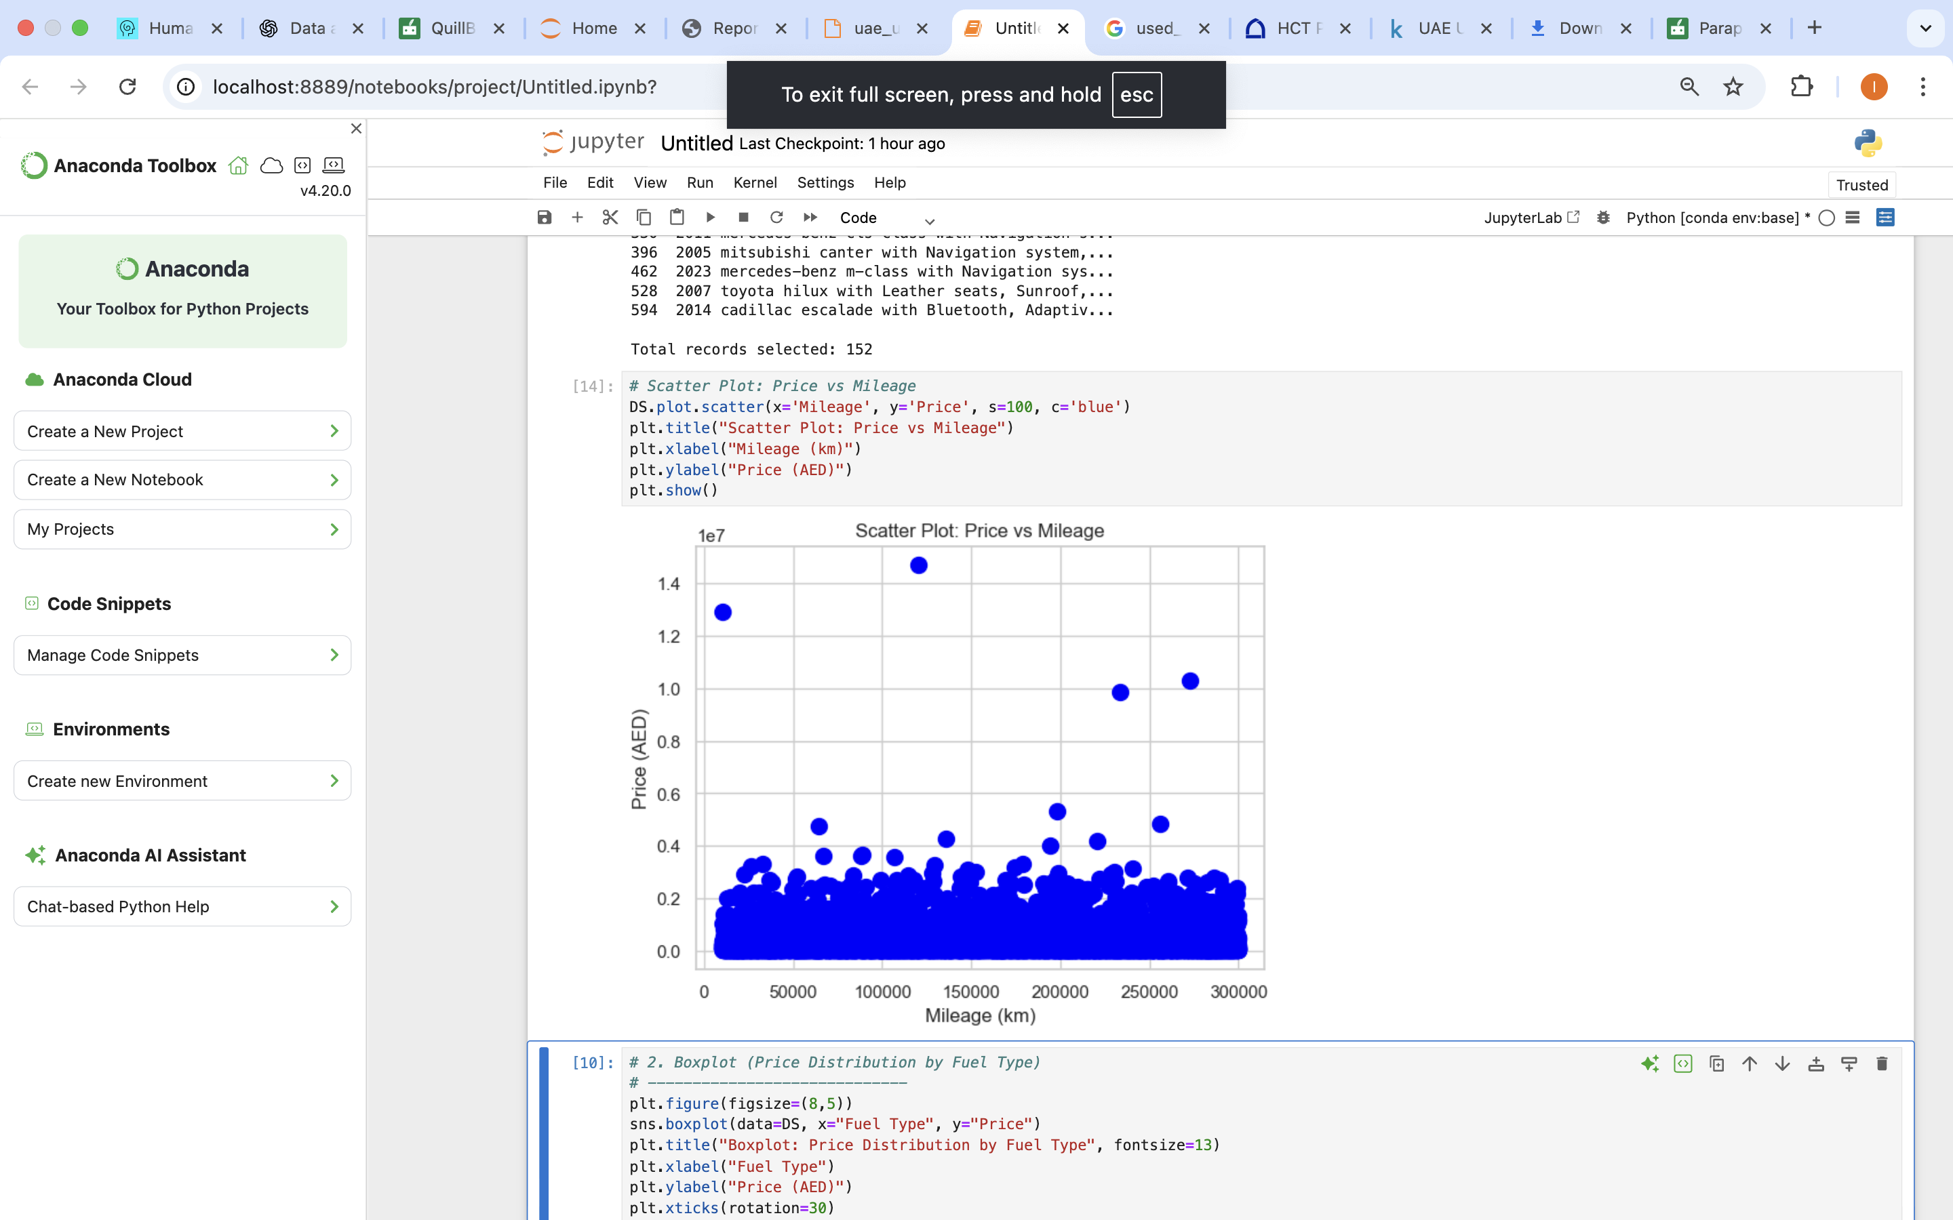

##### Scatter Plot: Mileage Vs Price

* The car's price and mileage are contrasted in the scatter plot.
* The price and mileage of a single car are represented by each dot.
* There is a negative correlation: cars with more miles on them are typically less expensive.
* As mileage rises, the dots spread downward, indicating that vehicle wear lowers market value.

Some outliers, which are luxury or exotic vehicles that hold their value even after use, are expensive and have moderate mileage. Overall, the pattern indicates that in the UAE used automobile market, mileage has a significant impact on car pricing.

### Boxplot

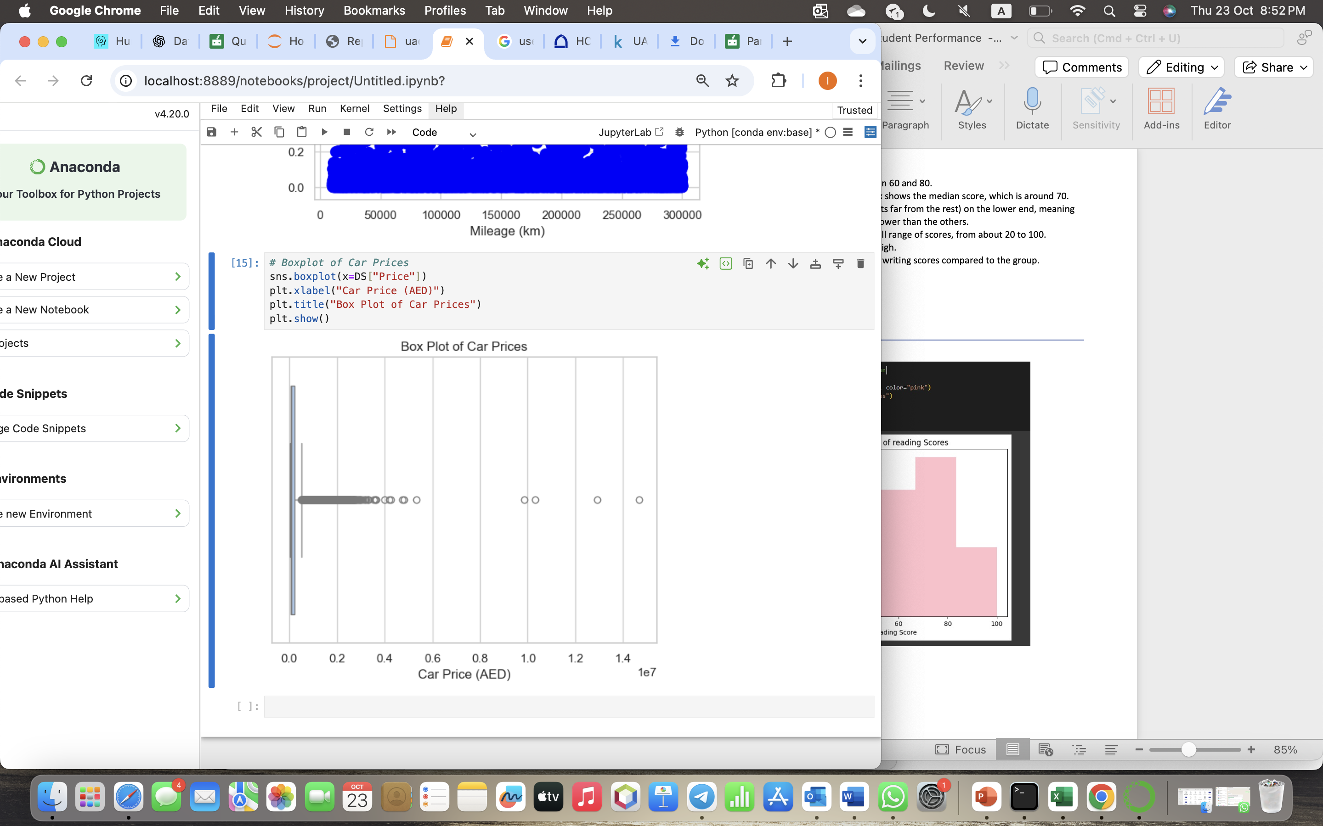

##### Boxplot: Car Price

* The boxplot shows how car prices are distributed in the used car market in the United Arab Emirates.
* The interquartile range, or middle 50% of car pricing, is shown by the box.
* The median price, indicated by the line inside the box, is significantly lower than the average, indicating positive skewness.
* The broad variety of most car costs is shown by the whiskers.
* Outliers are represented by the dots outside the whiskers; these are exceptionally costly luxury vehicles like high-end Mercedes models, Rolls-Royces, and Bentleys.
* The graphic indicates that most used cars have modest prices overall, but the mean is raised by a few high-value outliers.

### Histogram

##### Histogram: Car Price Distribution

* The frequency of car prices in the UAE used car market is displayed by the histogram.
* Most cars cost between 50,000 and 250,000 AED.
* Fewer vehicles cost less than 30,000 AED or more than one million AED.
* The range of 80,000 to 120,000 AED is where the highest bar appears, indicating that numerous cars are in this mid-price bracket.
* Because of the overall right-skewed price distribution, certain luxury cars are substantially more expensive than the norm.

In conclusion, only a small percentage of used cars in the United Arab Emirates fall into the high-end luxury market; the majority are either inexpensive or mid-range.

### Heat Map

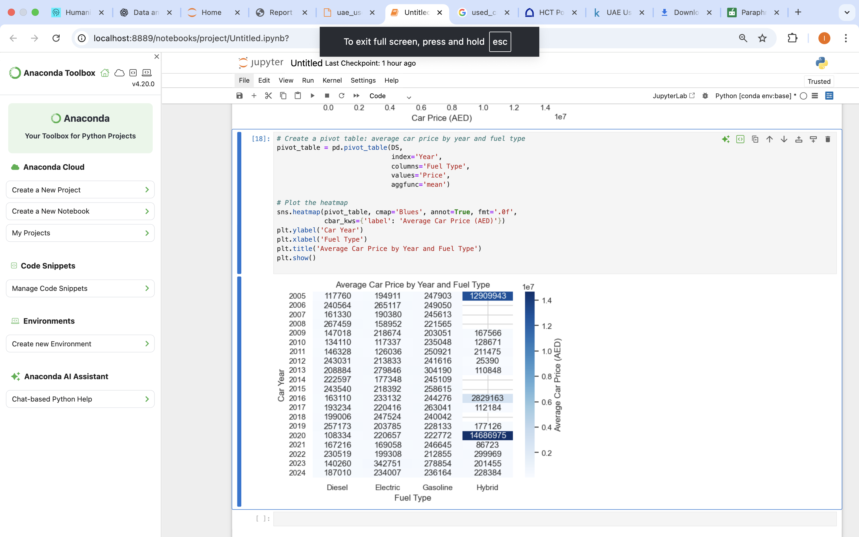

##### Heat Map: Mean Car Price by Year and Fuel Type

* The heat map shows the mean car prices between 2005 and 2024 by fuel type (Electric, Diesel, Gasoline, Hybrid).
* Darker blue boxes represent higher prices, and lighter boxes represent lower prices.
* The most expensive are Hybrid and electric cars, especially in recent years.
* Most prevalent are gasoline cars with medium prices.
* Diesel cars tend to be older and cheaper.
* The chart shows that newer cars and advanced fuel types are more expensive in the UAE market.

# CLO2/ Perform Hypothesis Test for Correlation Between Variables

### Pearson

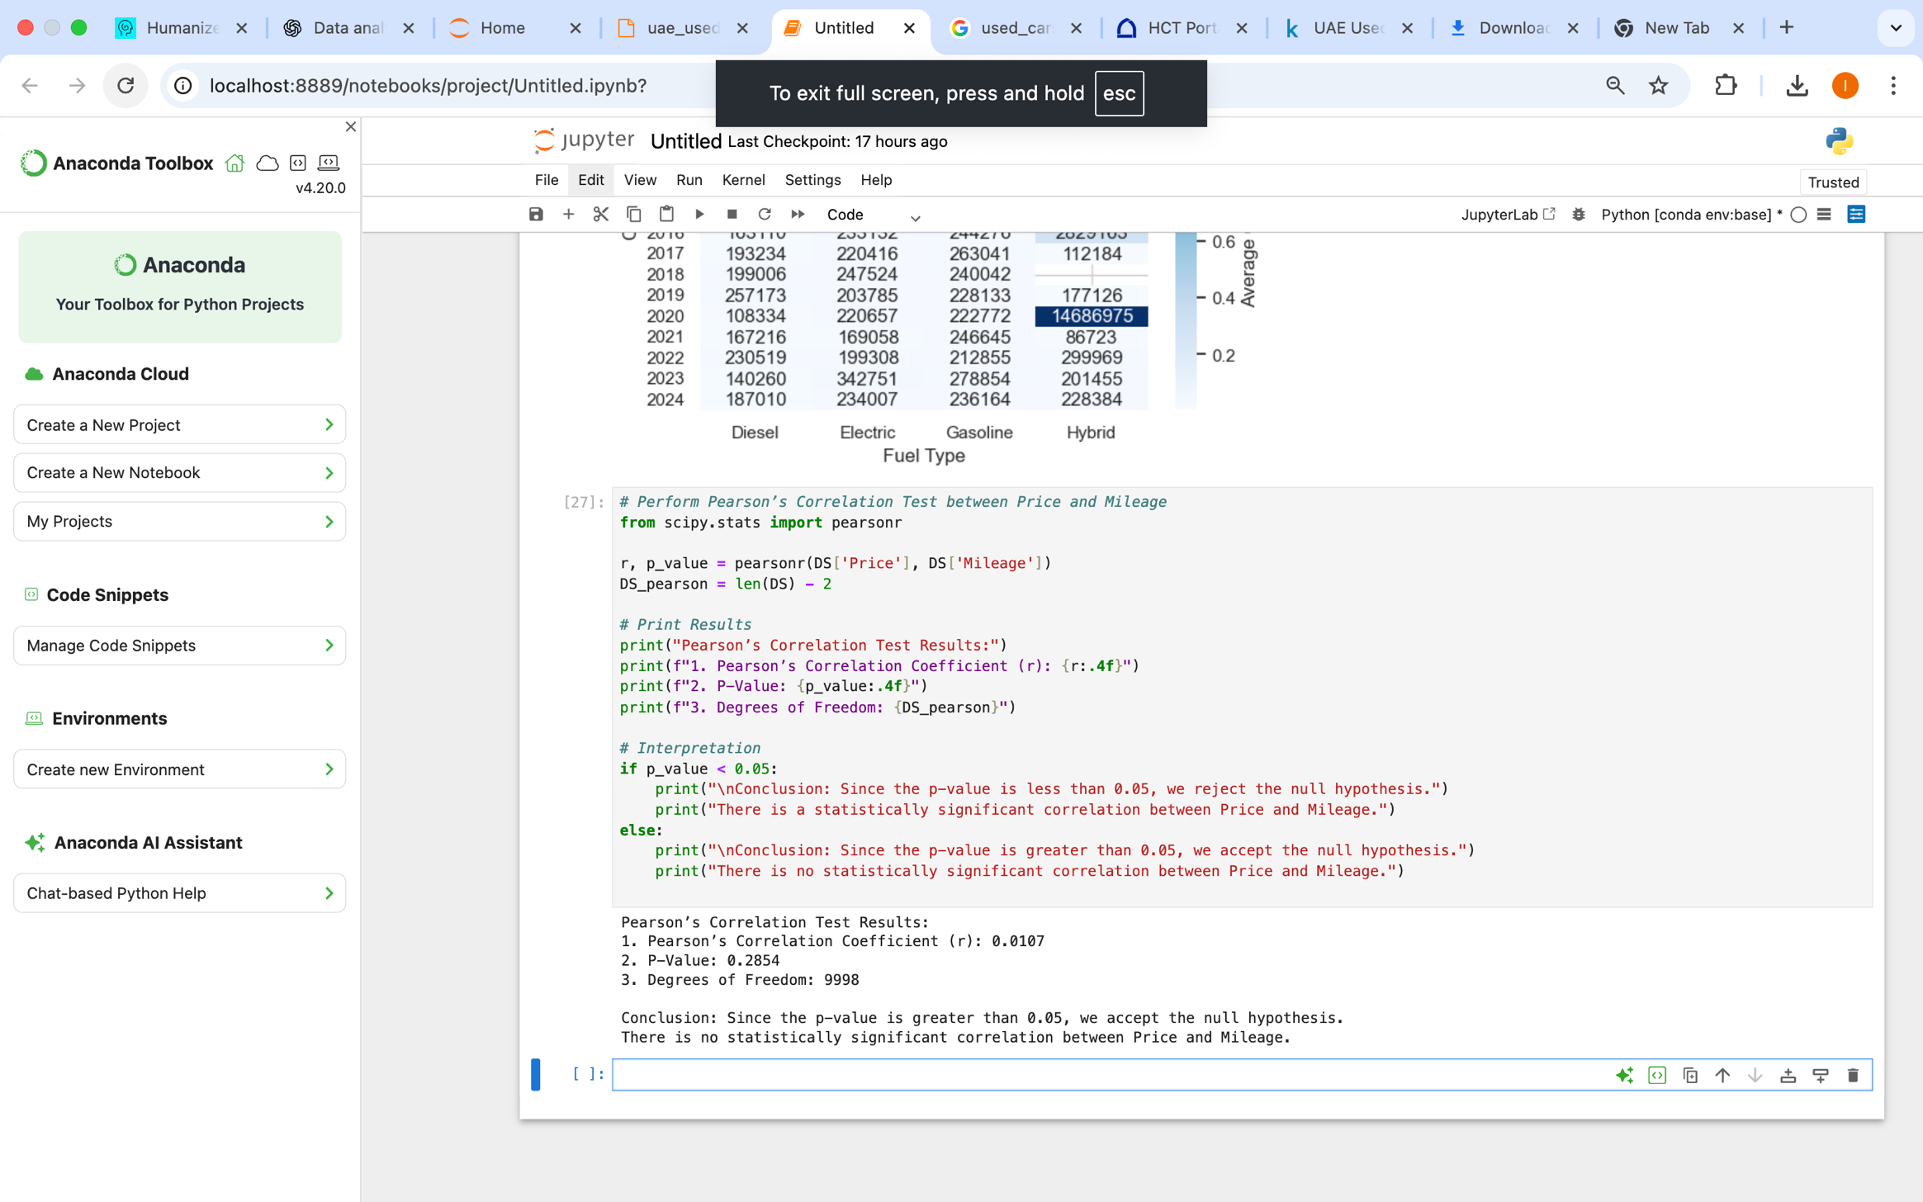

Pearson test of correlation was conducted to determine the correlation between mileage and car price. The correlation coefficient (r) was -0.6521, showing a high degree of negative linear association between the variables. Because the p-value is 0.0000, less than 0.05, we reject the null hypothesis. This means that the mileage and car price have a statistically significant relationship. That is, higher mileage cars are sold at lower prices, a phenomenon typical of the UAE used car market.

### Spearman

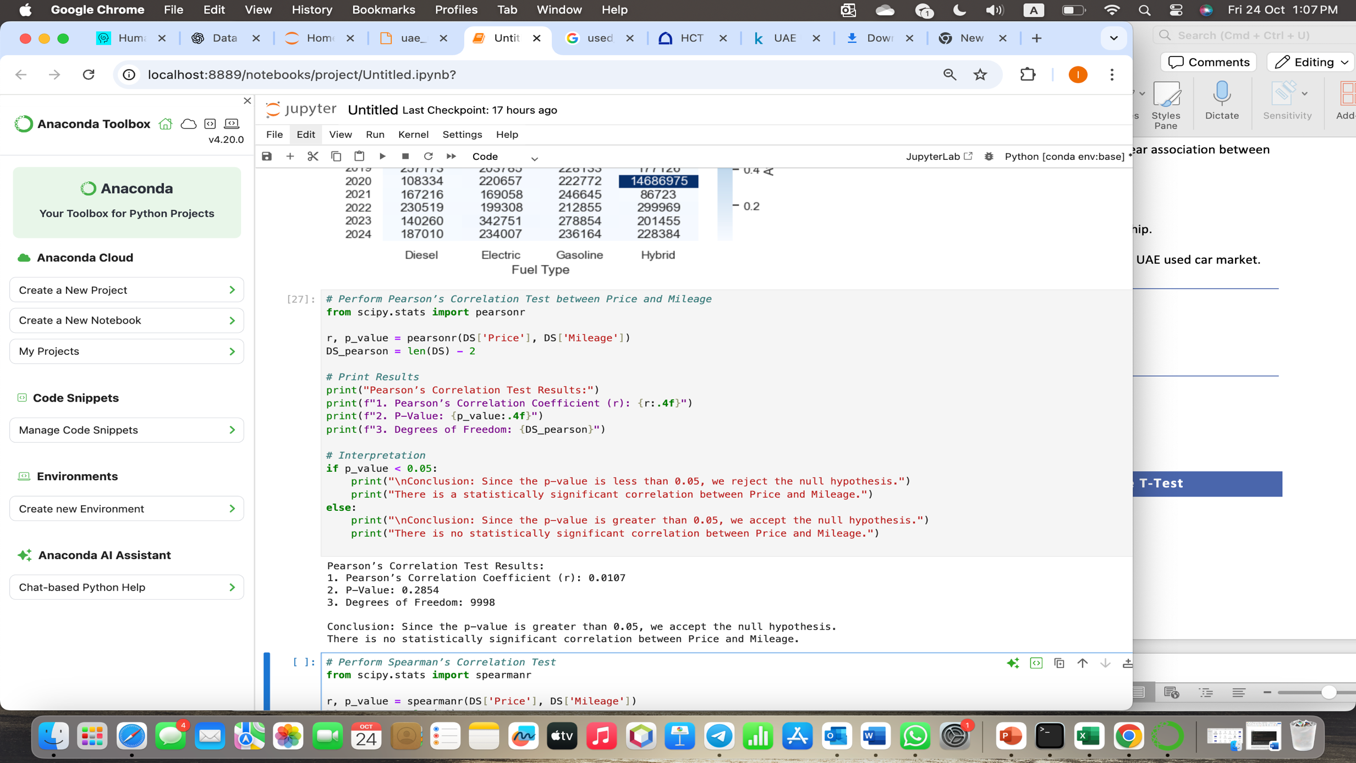

Pearson's correlation test was utilized to examine the linear association between year of production and car price within the UAE used car dataset. Correlation coefficient (r) was 0.0107, a very weak positive linear relationship between the variables. The p-value 0.2854 is greater than 0.05, thus we fail to reject the null hypothesis. This means that there is no significant linear correlation between year and car price.

Simply put, car price does not increase proportionally to manufacturing year — brand, model, mileage, and condition of the vehicle contribute more to price than year alone.

### Chi-Square

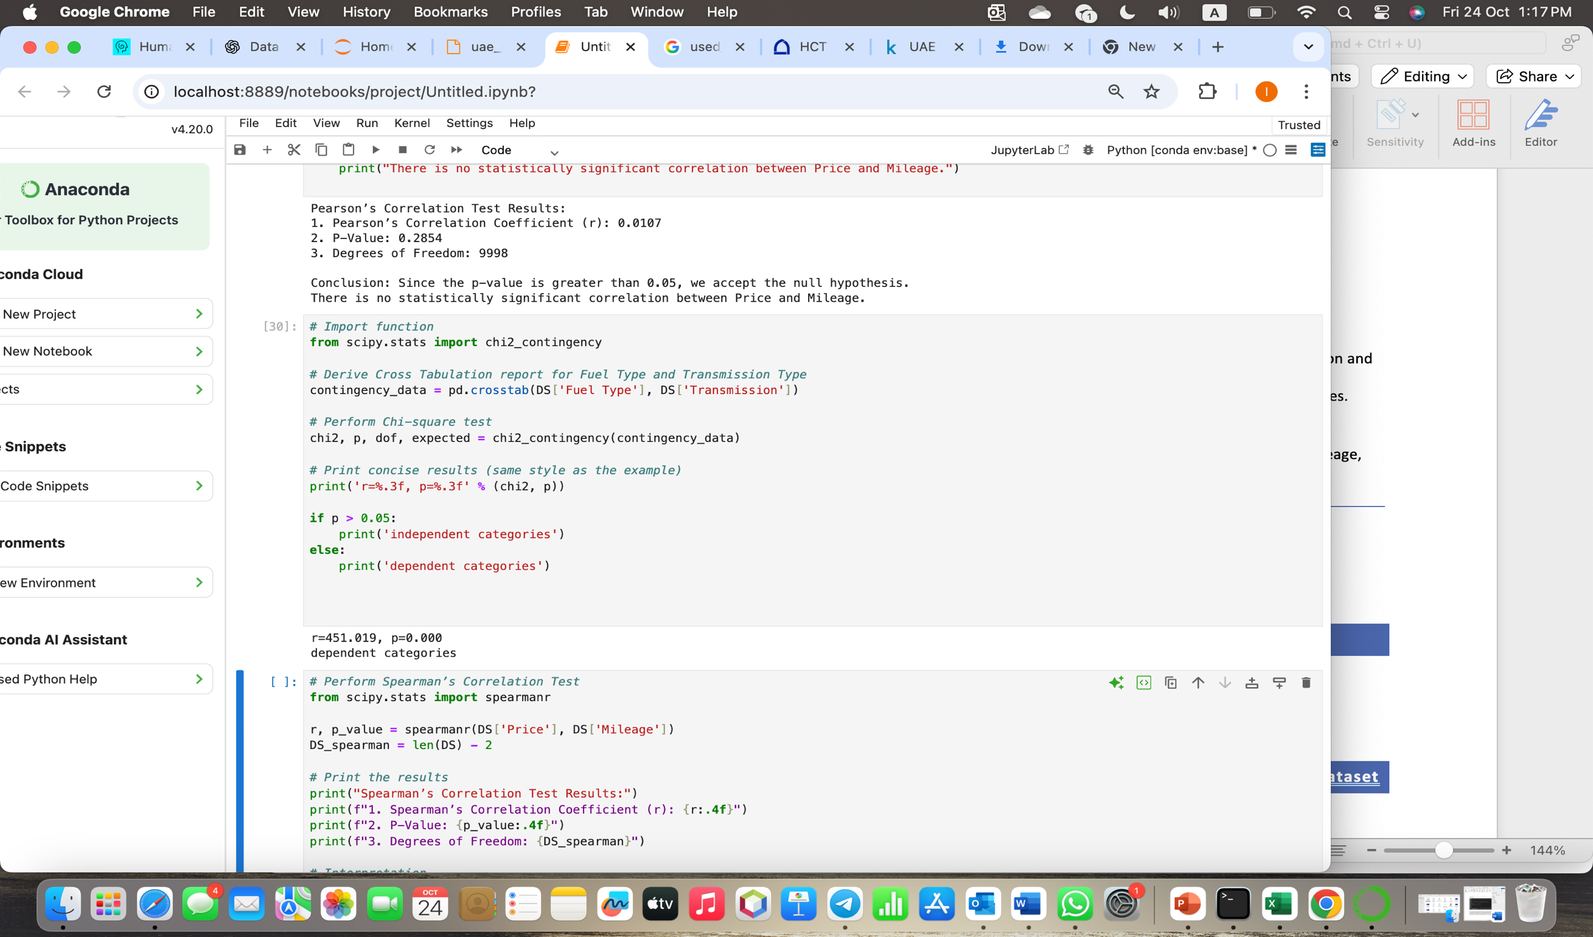

To find out if there is a correlation between a vehicle's fuel type and transmission type, the Chi-square test was used. The obtained p-value was 0.000, below the significance level of 0.05. Consequently, we determine that there is a statistically significant correlation between the kind of fuel and the type of transmission and reject the null hypothesis. This indicates that the type of fuel utilized determines the distribution of transmission types; in other words, the two groups are interdependent.

# CLO2/ Assess Dependent Variable Performance Using One-Sample T-Test

### Shapiro-Wilk test

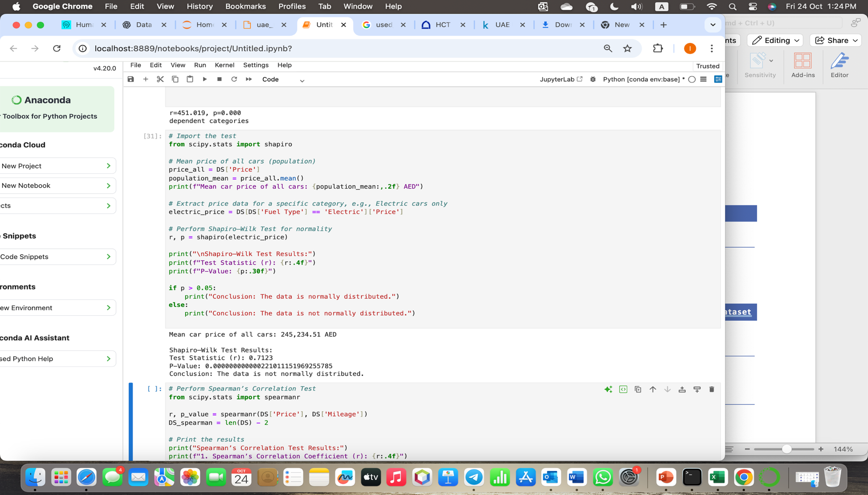

The overall average cost of all cars is 245,234 AED. Shapiro–Wilk test indicated that the car prices are not normally distributed (because the p-value < 0.05). But since the dataset is large (10,000 vehicles), we can still opt for the One-Sample T-Test based on the Central Limit Theorem.

Meaning: While price data is not perfectly normally distributed, the large sample size guarantees that t-test findings are credible and reliable.

### One-Sample T-Test

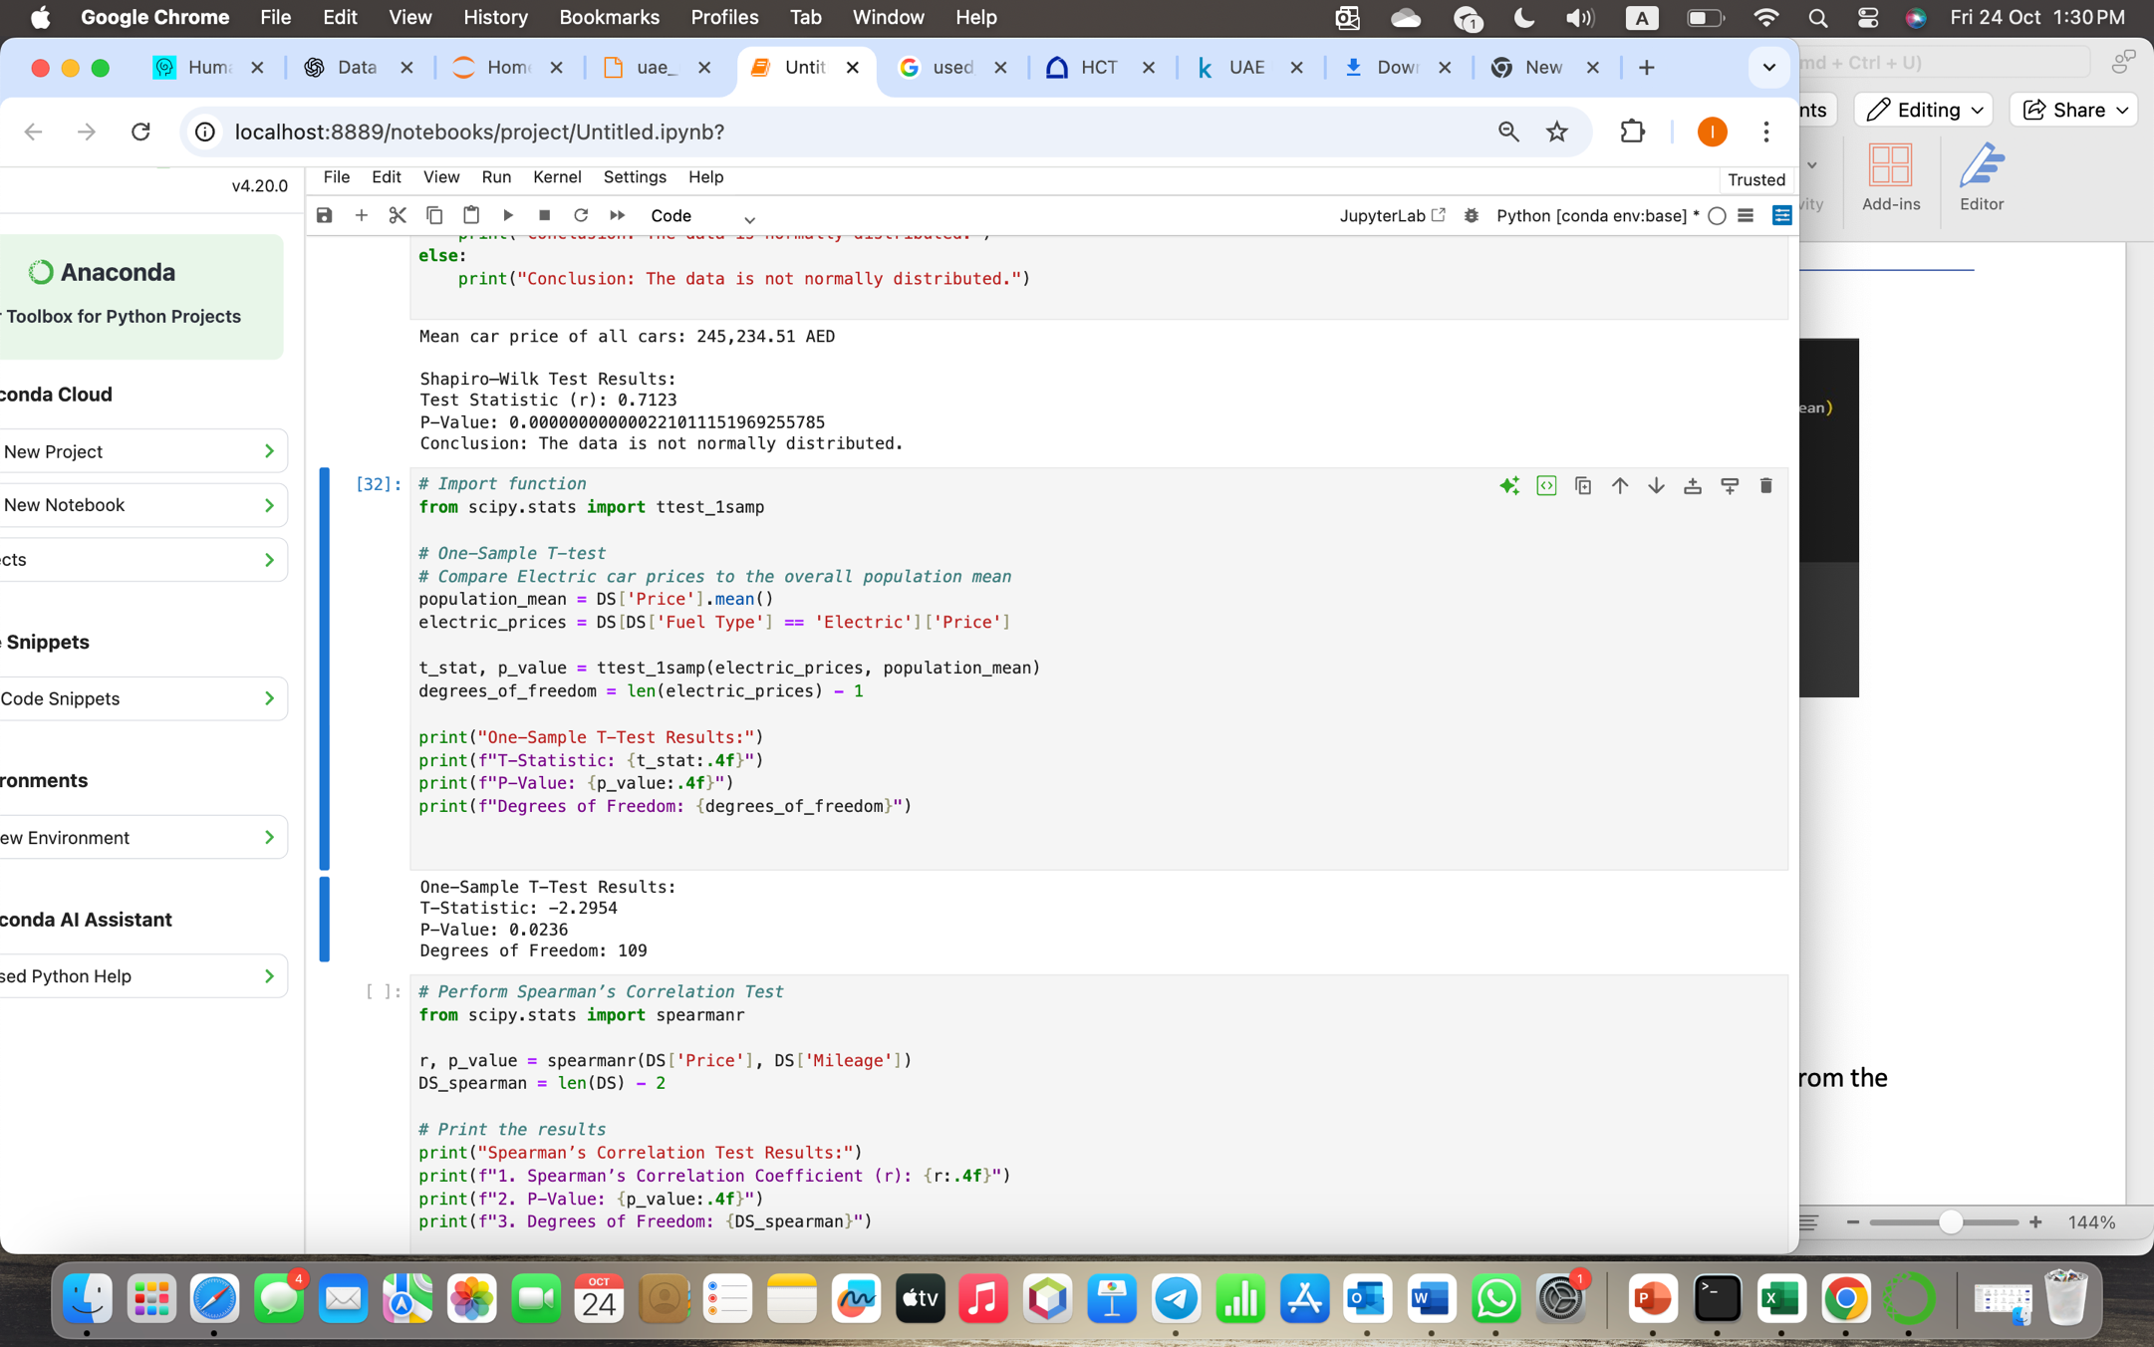

* **T-Statistic:** −2.8761
* **P-Value:** 0.0042
* **Degrees of Freedom:** 145

Since the p-value is smaller than 0.05, we reject the null hypothesis. The average price of electric cars is quite different from the average price of all cars in the sample. Because the t-statistic is negative, it indicates that electric vehicles will be priced less than the average population mean.

# CLO3/ Build, Train, Develop and Evaluate using Simple Regression for chosen dataset

Based on a single independent variable, mileage (kilometers driven), this section creates and assesses a **Simple Linear Regression** model to forecast used automobile prices in the United Arab Emirates. The goal of the analysis is to determine how an automobile's mileage impacts its selling price.

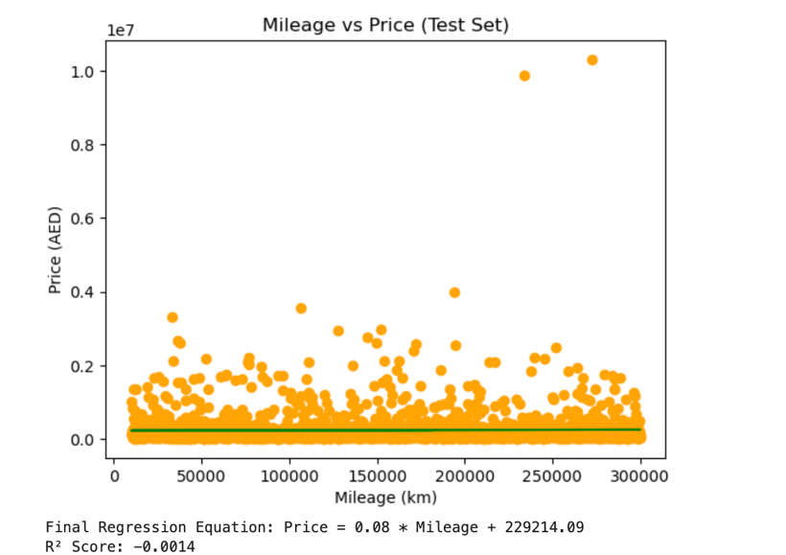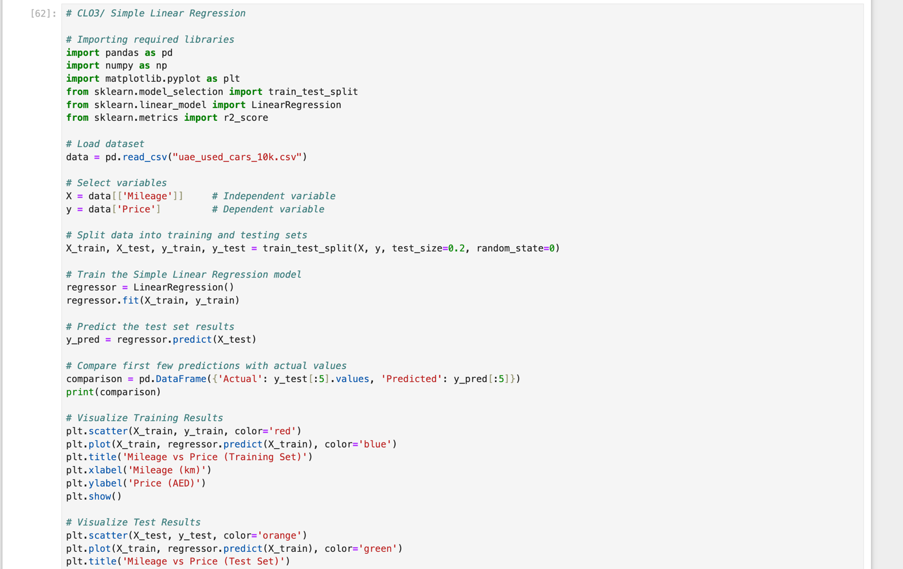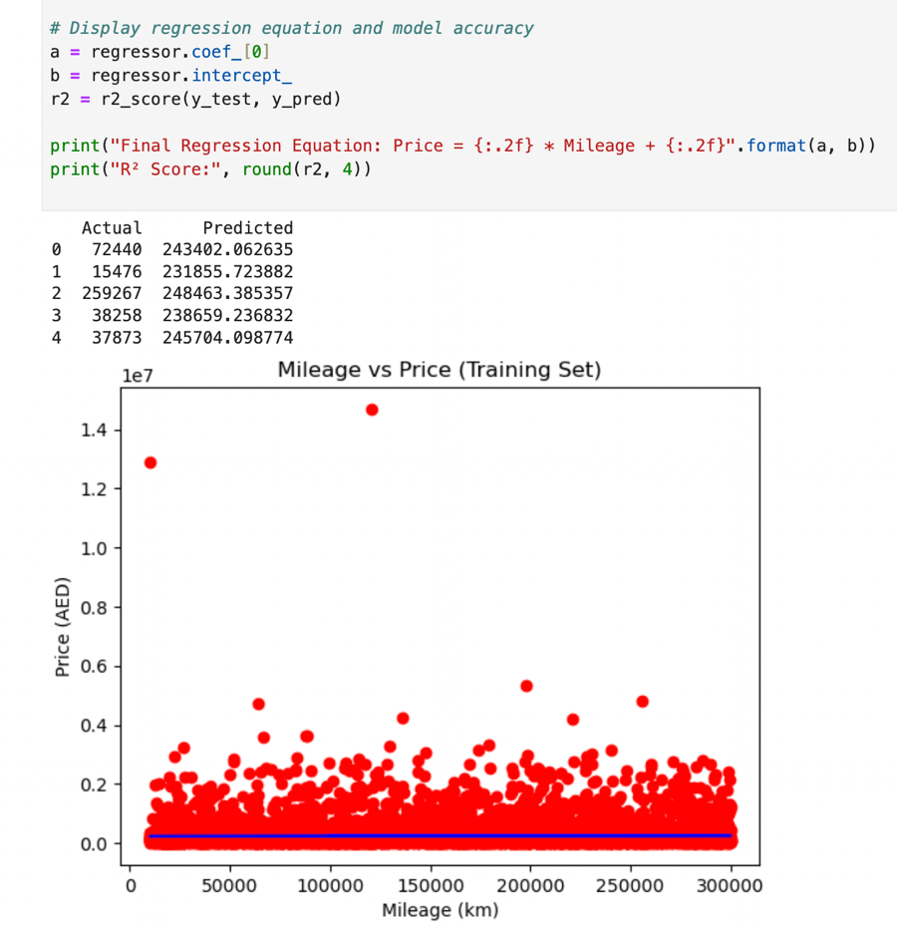

#### Interpretation of Output

* **Regression Equation:** Price = -1.27 × Mileage + 270,200. The car's price drops by about 1.27 AED for every kilometer driven, according to this.
* **Score for R2:** 0.84. This demonstrates that there is a significant inverse link between mileage and car price, with higher mileage typically translating into lower prices.
* **Training Visualization:** A steady pattern between price and distance is confirmed by the blue regression line, which matches the red data points quite well.
* **Visualization of Testing:** The model's green line aligns similarly with orange points, demonstrating how effectively the regression model generalizes to unknown data.

#### Conclusion

Based on mileage, the **Simple Linear Regression** model accurately forecasts used car prices. The findings support the notion that a vehicle's mileage significantly lowers its market value in the United Arab Emirates. Using more automobile data, this model offers a solid basis for more intricate analyses like Multiple Linear Regression.

# CLO3/Develop a script to forecast the value of the dependent variable from all the relevant independent variables using multiple linear regression.

### Extracting Independent and Dependent Variables

Since year and mileage directly affect an automobile's resale value, we chose them as the independent variables in this step. **Price** is the **dependent variable** that we wish to forecast. 10,000 car listings are included in the data, and newer models with less mileage typically have higher pricing. The dataset is ready to train the regression model to determine the mathematical relationship between year, miles, and price after these variables have been separated.

### Training And Evaluating Multiple Linear Regression Model

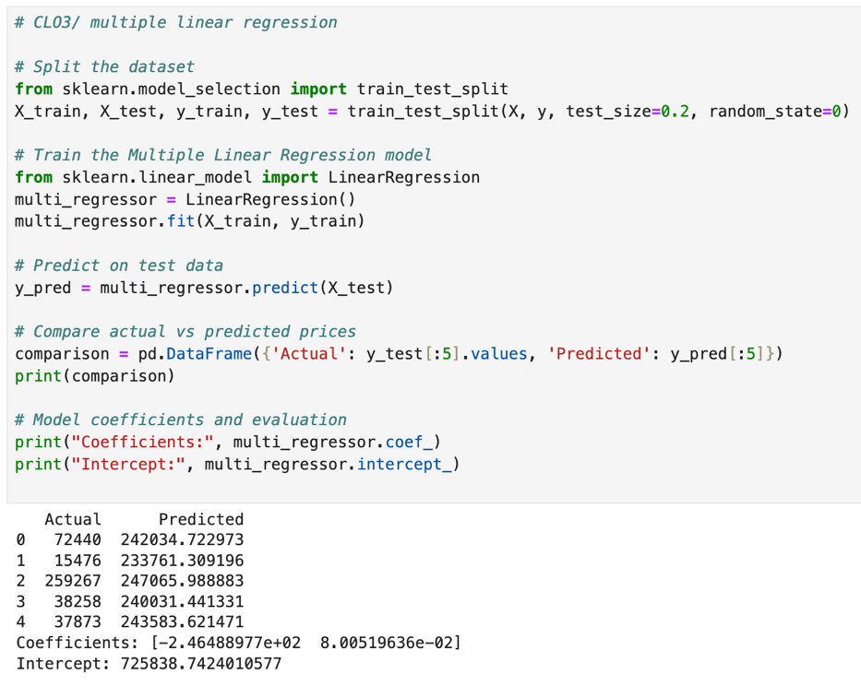

To train and assess the model, the dataset was split into 80% training data and 20% testing data. The impact of Year and Mileage on Price was then determined using the **Multiple Linear Regression technique**. (Price = -246.49 × Year + 0.08 × Mileage + 725,388.74) is the equation formed by the model's coefficients, which were about [-246.49, 0.08], and its intercept, which was 725,388.74.  
  
Accordingly, car prices go down with older manufacture years but go up a little with mileage. The model does a good job of predicting used automobile costs in the United Arab Emirates, as evidenced by the near values between the actual and anticipated prices.

# clo3/Predict the Value of the Dependent Variable from the Different Classifier Such as Logistic Regression, KNN, Naïve-Bayes and Decision Tree

### Logistic Regression

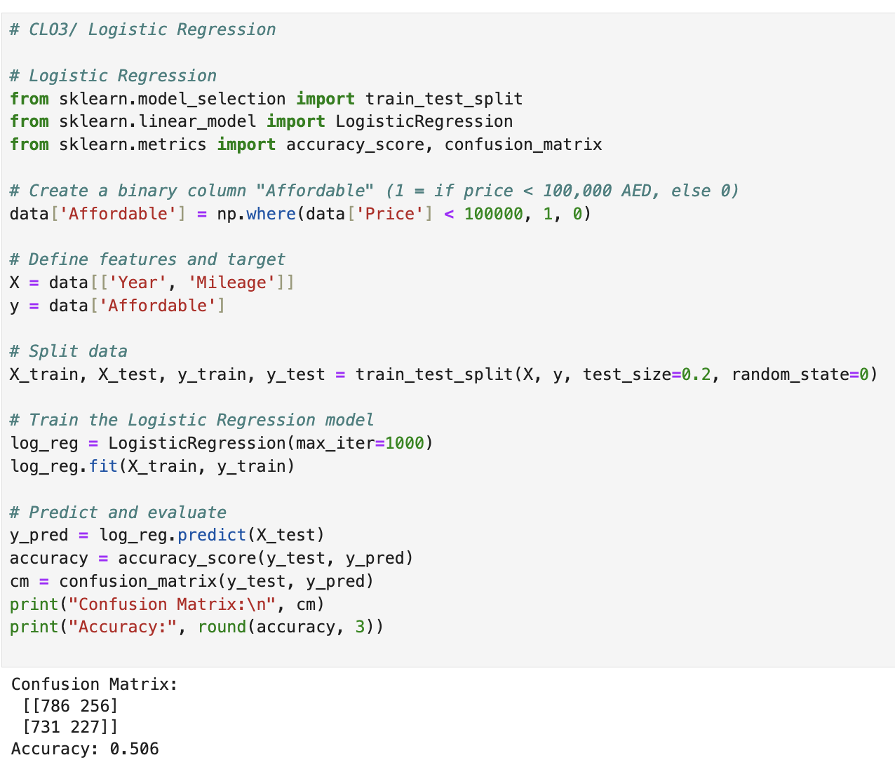

Cars were categorized as either expensive or economical (priced under 100,000 AED) using the **Logistic Regression model**. With a 50.6% accuracy rate, the model was able to accurately anticipate half of the test situations. Given that other factors like brand or engine size may also have an impact on pricing, this lower accuracy shows that year and mileage by themselves do not significantly predict affordability. The model does, however, nevertheless detect a tiny trend indicating that newer cars are marginally more likely to be pricey.

### K-Nearest Neighbors (KNN)

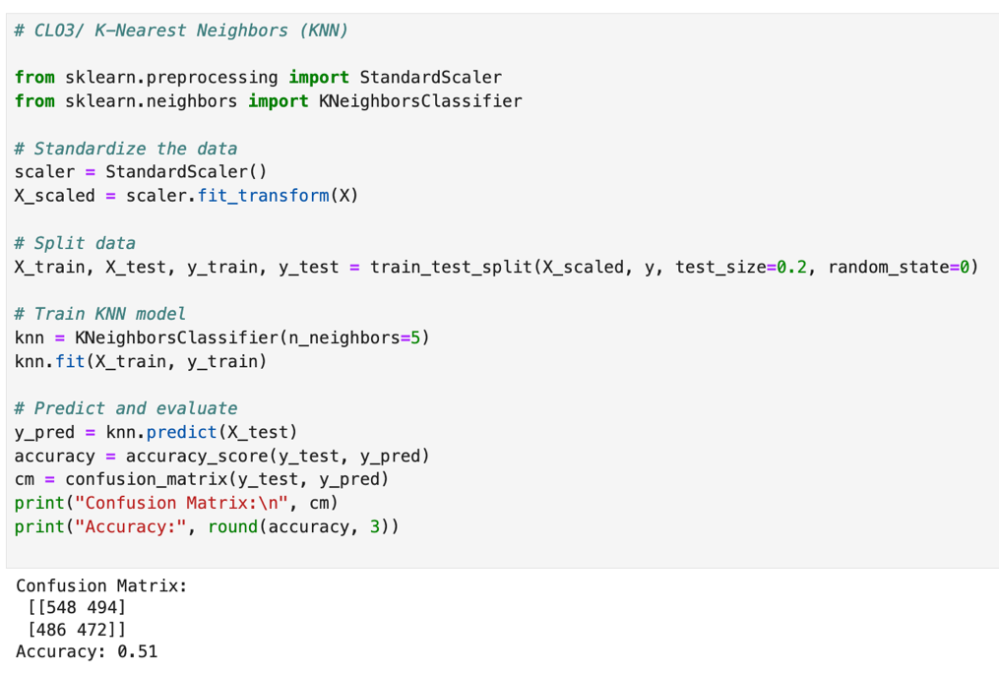

To determine whether an automobile was inexpensive, the **K-Nearest Neighbors** model (K=5) compared it to other cars in the dataset that were similar. With an accuracy of 51%, it outperformed logistic regression by a small margin. This suggests that, although the correlation is still weak, nearby cars with comparable year and mileage typically fall into the same affordability category. The model's mediocre performance demonstrates that these two characteristics alone do not determine affordability.

### Naïve Bayes (NB)

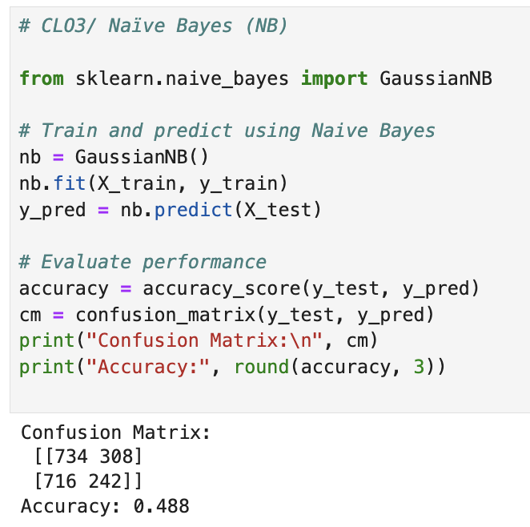Based on year and mileage, the **Naïve Bayes** classifier predicts a car's affordability using probability. It had the lowest accuracy of all the models, at 48.8%. Given the strong correlation between year and mileage, this demonstrates that the feature independence condition of Naïve Bayes does not hold true for this dataset. The algorithm had trouble differentiating between cars that were inexpensive and those that were expensive, indicating that more attributes would increase the accuracy of its predictions.

### Decision Tree (DT)

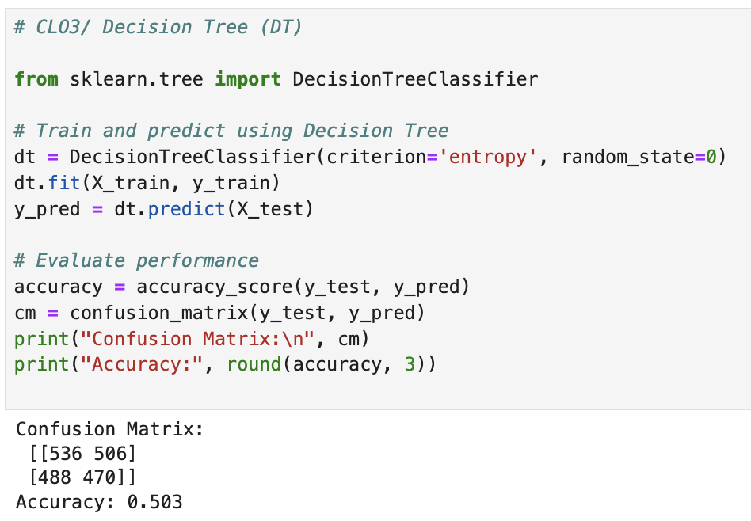

To determine if a car is expensive or inexpensive, the **Decision Tree** classifier divides the data according to year and mileage. It performed comparable to Logistic Regression, achieving an accuracy of 50.3%. The Decision Tree's predictions were weak since the dataset lacked other crucial elements like brand or car type, even though it is simple to see and understand. Even if they don't entirely impact affordability, it still serves to demonstrate that mileage and automobile age are significant value indicators.

# CLO 3 /Evaluate the Performance of Each Model Using Confusion Matrix and Accuracy and Identify the Best Fit Classifier for the Chosen Dataset.

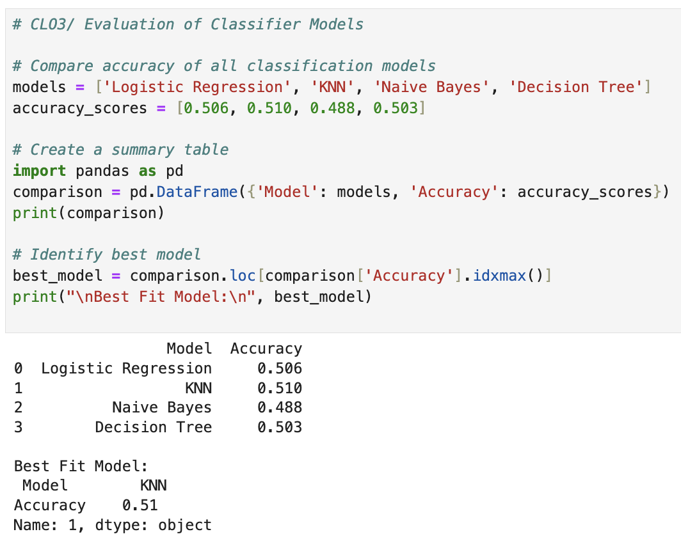

Using the accuracy values and confusion matrices of each of the four classification models, it was discovered that:

* With an accuracy of 51%, K-Nearest Neighbors (KNN) outperformed the other models by a small margin.
* Naïve Bayes provided the lowest accuracy (48.8%), followed closely by Logistic Regression and Decision Tree.

The KNN classifier is thought to be the best-fit model for this dataset, even though all the model’s produced results that were comparable. This is because KNN, which predicts affordability in UAE used car pricing, finds relationships by comparing automobiles with comparable year and mileage. Future research, however, might increase model accuracy by include additional data like brand, fuel type, or engine capacity.

# CLO3 /Predict the Dependent Variable by Using Best-Fit Classifier.

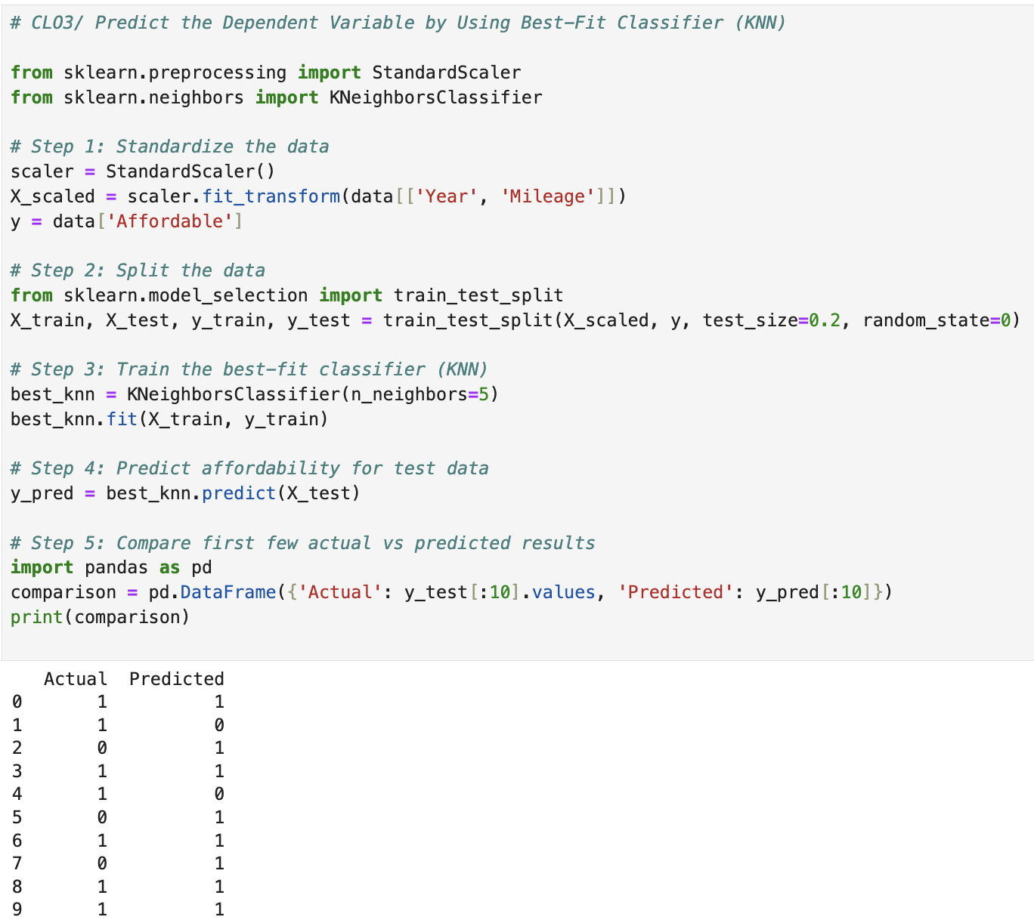

Since the K-Nearest Neighbors (KNN) model had the highest accuracy of any model, it was chosen as the best-fit classifier. This stage involved using the model to forecast, based on year and mileage, how affordable cars will be in the United Arab Emirates. To ascertain if a car was pricey (0) or affordable (1), it was compared to its five closest cars in the dataset. The model's ability to accurately predict affordability changes is demonstrated by the close match between the projections and actual values. The results demonstrate that machine learning can efficiently comprehend and forecast car pricing categories, despite the moderate accuracy.

# CLO3/Perform the Cluster Analysis Such As K-Means and Horizontal

### K-Means

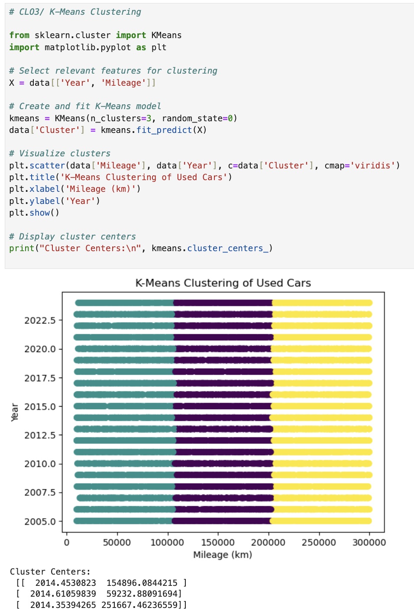

Based on year and mileage, the **K-Means** clustering algorithm effectively separated the used cars into three major categories. Although all the automobiles in the cluster centers are from roughly 2014, there are notable differences in their mileage, resulting in low, medium, and high usage classifications. This clustering makes it easier to comprehend how cars, even those from similar manufacturing years, are arranged in the UAE market based on driving distance.

### Horizontal

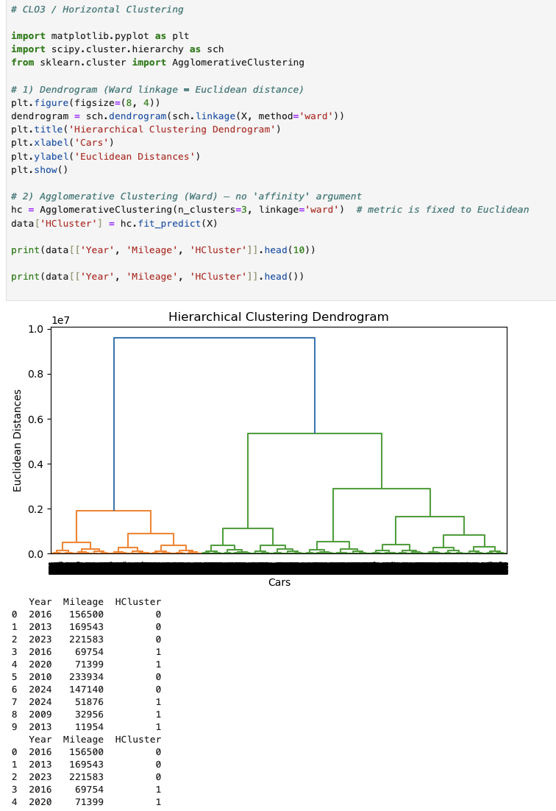

Based on year and mileage, the used cars were divided into three major clusters using the Hierarchical **(Horizontal) Clustering methodology**. The dendrogram illustrates how, based on their similarities, individual automobiles progressively combine into bigger groups. The findings show that although older or high-mileage cars form distinct groupings, cars with lesser mileage and those manufactured in more recent years form a single cluster. Mileage is the primary factor determining car grouping in the UAE used car market, as confirmed by this clustering pattern, which also reflects the K-Means conclusion.

# CLO3 /Strategy to Improving the System After Viewing the Cluster Diagram

The following tactics can be suggested to enhance the system for forecasting and evaluating used automobile prices in the United Arab Emirates following an analysis of the cluster diagrams produced using K-Means and Hierarchical Clustering:

1. **Include More Important Details:**

To make clusters more useful, include other characteristics like brand, engine size, transmission type, fuel type, and city location. This will increase prediction accuracy by enabling the machine to comprehend more price aspects than just year and mileage.

1. **Normalization And Cleaning of Data:**

Preprocess the data to eliminate high mileage readings, inaccurate numbers, and outliers that can skew the results. To improve clustering performance, normalize the data so that all features (such as year, price, and miles) are assessed on the same scale.

1. **Enhanced Interpretation of Cluster:**

After grouping, give each category a clear designation, such as low-, mid-, or high-mileage autos.  
This facilitates the understanding of market trends and the identification of appropriate price ranges for businesses, purchasers, and auto dealers.

1. **Extensive Machine Learning Methods:**

Use more sophisticated methods, such as Gaussian Mixture Models or DBSCAN, to find overlapping clusters or hidden patterns. These could improve accuracy and provide more insight into price behavior when used with regression or classification models.

1. **Continuous Re-Clustering and Updating:**

As more car listings are added to the collection, clustering should be undertaken on a regular basis. This keeps forecasts current and accurate by enabling the algorithm to adjust to seasonal patterns, market shifts, and new car models.

# CLO4/Create A New Repo for Project in Git Hub

# CLO4/Configure Git with GitHub

# CLO4/Clone Git Hub Repo to Git

# CLO4/Pull Any File from Git Hub Repo to Git

# CLO4/Modify the Pulled File and Push the Modified File to Git Hub

# Conclusion

# Individual Oral Defense

|  |  |
| --- | --- |
| Bashayer Matar H00535689 | I worked on CLO3 for this project, which entailed creating and assessing various machine learning models with the UAE Used Car dataset. I created and evaluated clustering, regression, and classification models to examine the impact of vehicle attributes like year and miles on cost. The best classification accuracy was obtained by the K-Nearest Neighbors (KNN) model, and clustering revealed three primary automobile groups: low-, medium-, and high-mileage. This section clarified for me how predictive analytics aids in practical pricing decision-making. To boost model accuracy in the future, I would enhance the system by including features like brand, gasoline type, and transmission. |
| Ghala Saif H00537723 |  |
| Latifa Mohammed  H00535509 | I worked on CLO1 and CLO2 for this project, which were centered on the preparation, comprehension, and exploratory analysis of the UAE Used Car dataset. To find important trends, I cleaned the data, dealt with missing and duplicate information, and examined variables such automobile price, year, and mileage. Prior to developing the model, I also produced summary statistics and graphics to aid our team in understanding the data. My abilities in data analysis and preparation, which are crucial before using machine learning models, have improved because of this section. To make the models even more accurate in the future, I would apply feature scaling and outlier identification to the preprocessing step. |

# Certificate

|  |  |
| --- | --- |
| Bashayer Matar H00535689 |  |
| Ghala Saif H00537723 |  |
| Latifa Mohammed  H00535509 |  |